Problem Set 4 for Exam 4 Key

- Give an unambiguous IUPAC or common name for the following compound. Be sure to use cis/trans, E/Z or R/S where appropriate.
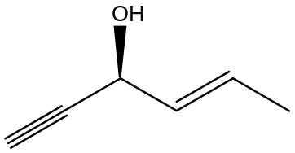

hex-(4E)-en-1-yn-(3S)-ol

- Draw the structure of the following alcohols:

i) 3-methyl-2-buten-1-ol ii) cis-1,3-cyclohexanediol

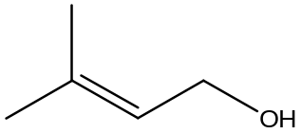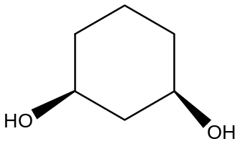

- Which of the following compounds is more water-solubility? Explain why.

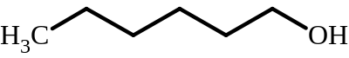 or 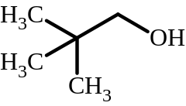

The alcohol on the right is more water-soluble. The more ball-like shape minimizes the non-polar surface area, so the proportion of polar to non-polar surface area is less than with the more linear molecule on the left. The left molecule also is larger (my mistake).

- Which of the following compounds has the higher boiling point? Explain why.

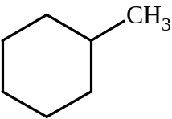 | or | 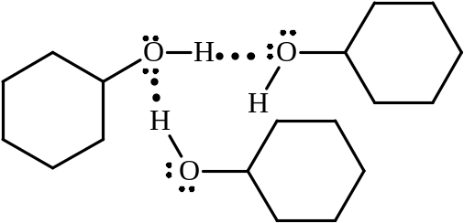
Methylcyclohexane has only London dispersion forces to attract it to other molecules of itself. |  | Cyclohexanol can hydrogen-bond to other molecules of itself, and has London dispersion forces, too, so it is higher boiling. More attractive forces implies more energy is needed to separate molecules.

- Which of the following compounds is the strongest acid, explain?

A. B. C. D.
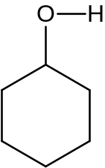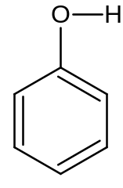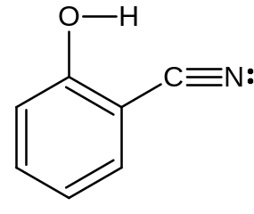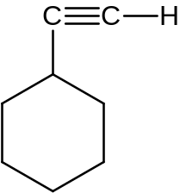

C: The cyano group can delocalize the charge from the negative O after ionization.

- Write arrow-pushing mechanisms for each of the following reactions.

a.
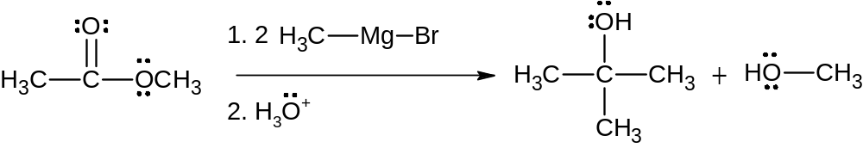

Answer
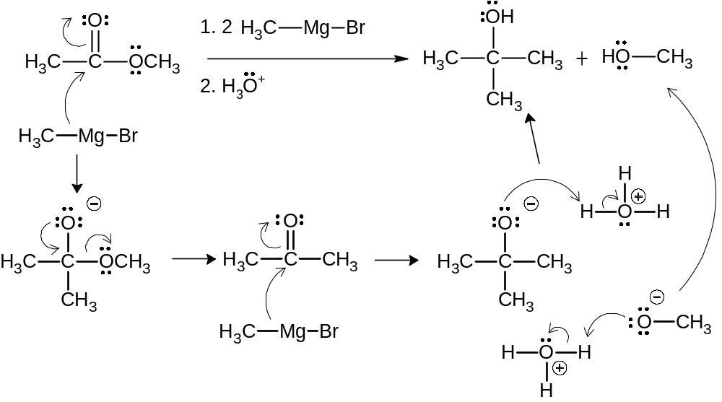

b.

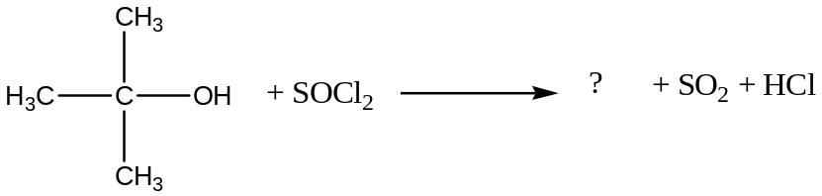

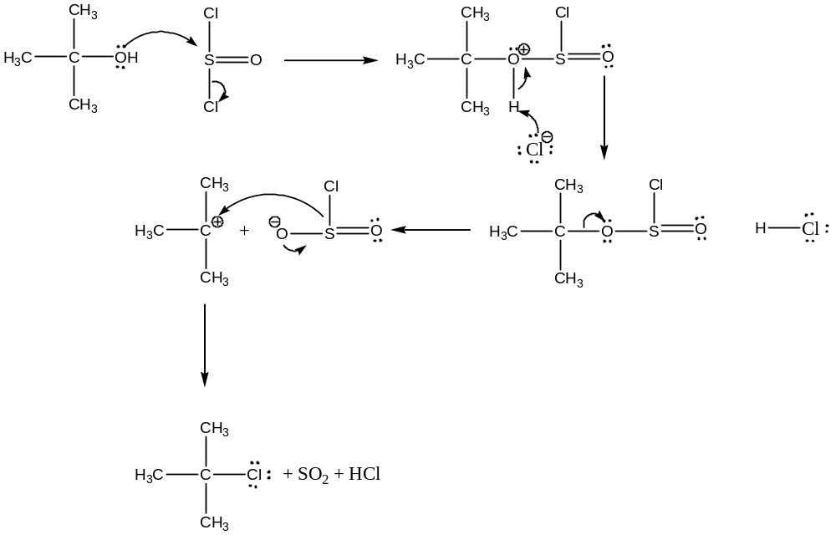

c)
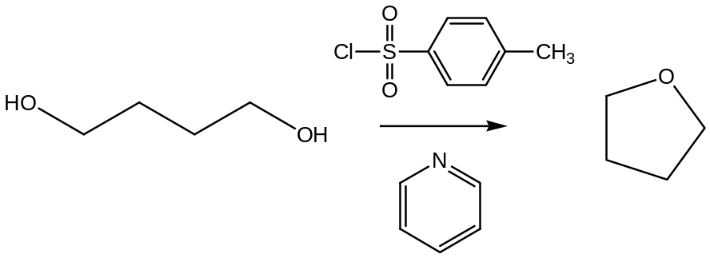

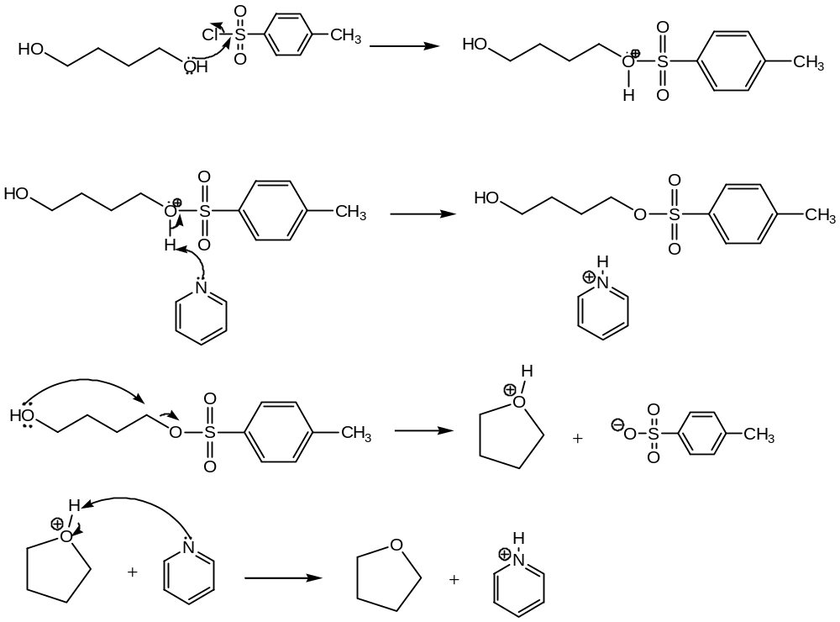

- Give the major organic products of each of the following reactions. Show stereochemistry when needed. If no reaction will occur, write “No Reaction”.
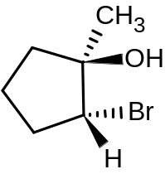

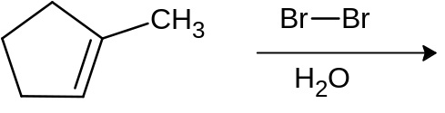

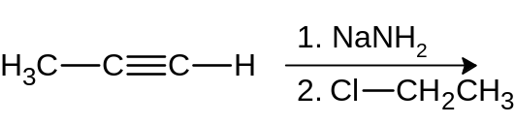
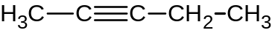

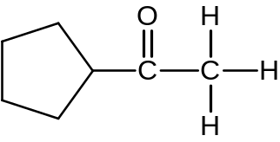
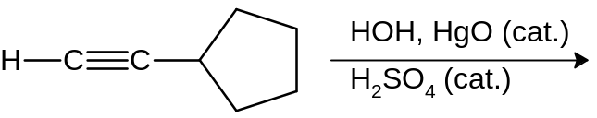

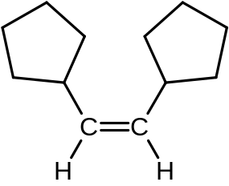
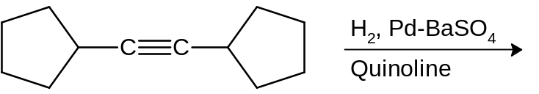

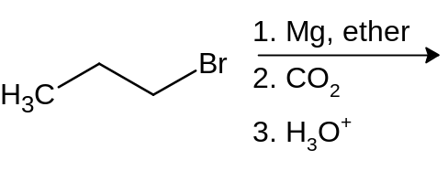
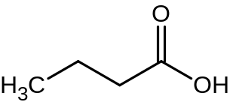

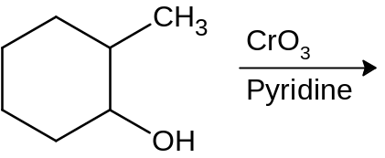
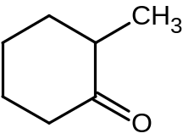

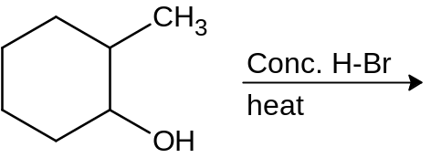
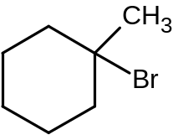

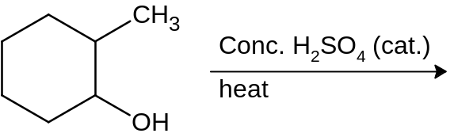
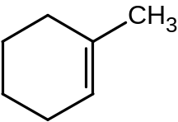

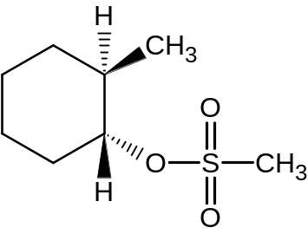
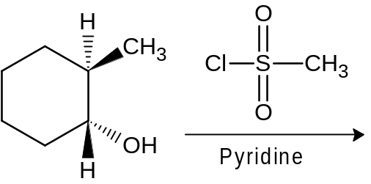

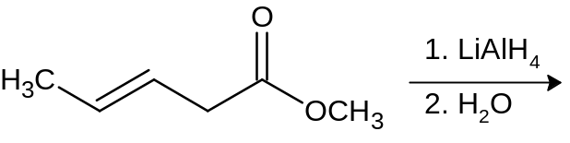
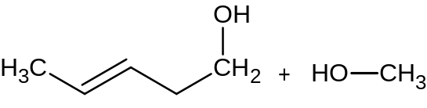
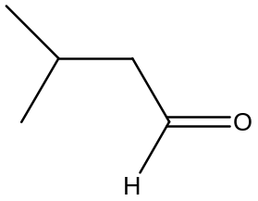

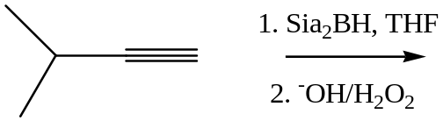

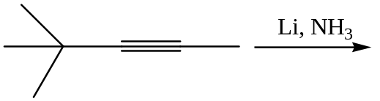
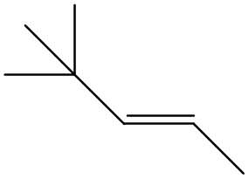

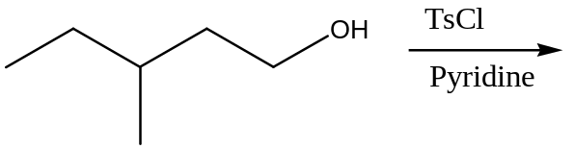
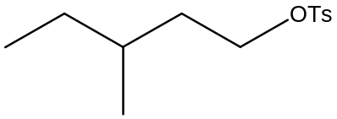

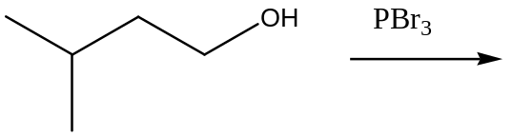
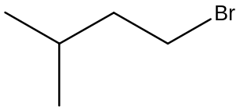

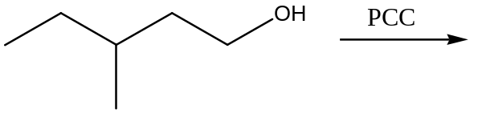
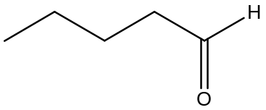

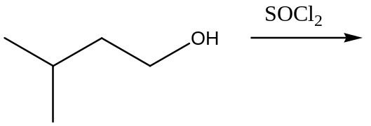
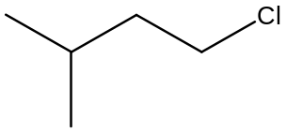

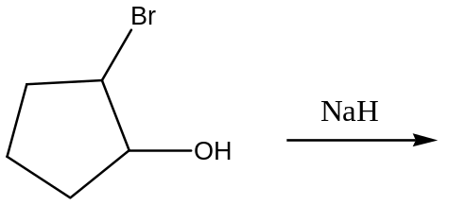
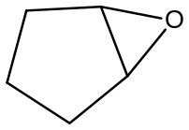

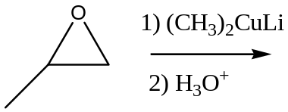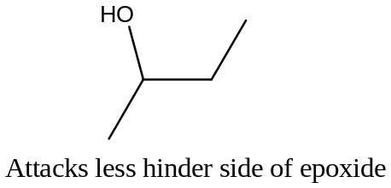

- Show how the following products could be made from the indicated starting materials.

Product Starting Material
a.
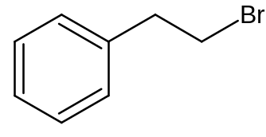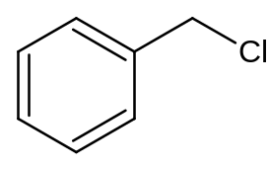

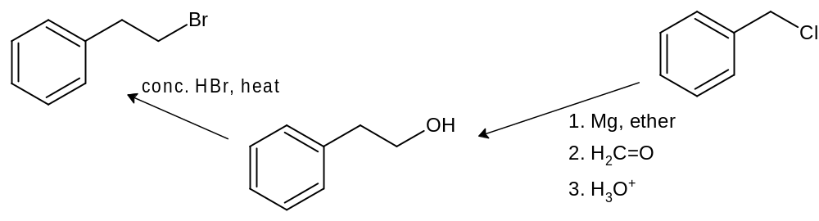

b.
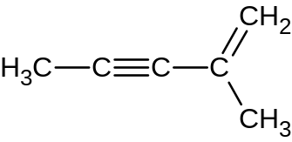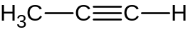

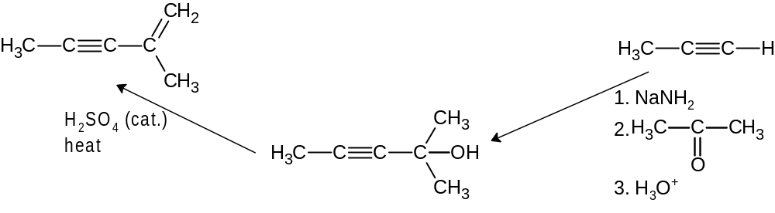

c.
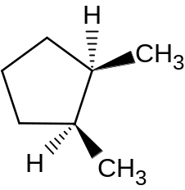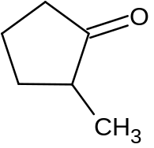

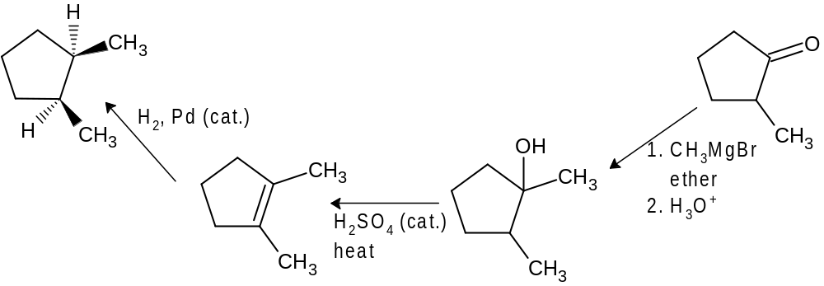

d.
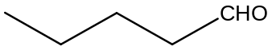
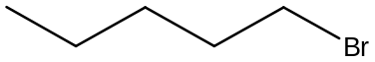

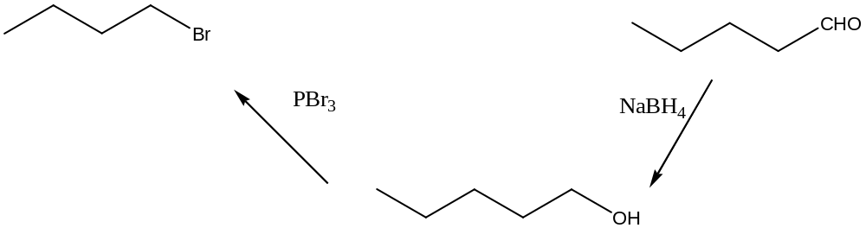

- Propose a multistep synthesis of the product shown below from the given starting materials, along with any reagents we have covered in class. You might discover multiple answers to this problem; draw only your best (one) synthetic route. Feel free to draw an incomplete route—we will give you partial credit where I can


